Kevin Chung

Period 5

12/16/19-12/20/19

Journal 13

This week I worked on the lattice point detection some more. My progress is shown in the image below, where a green circle indicates a positive lattice point according to the CNN and a red is a negative.

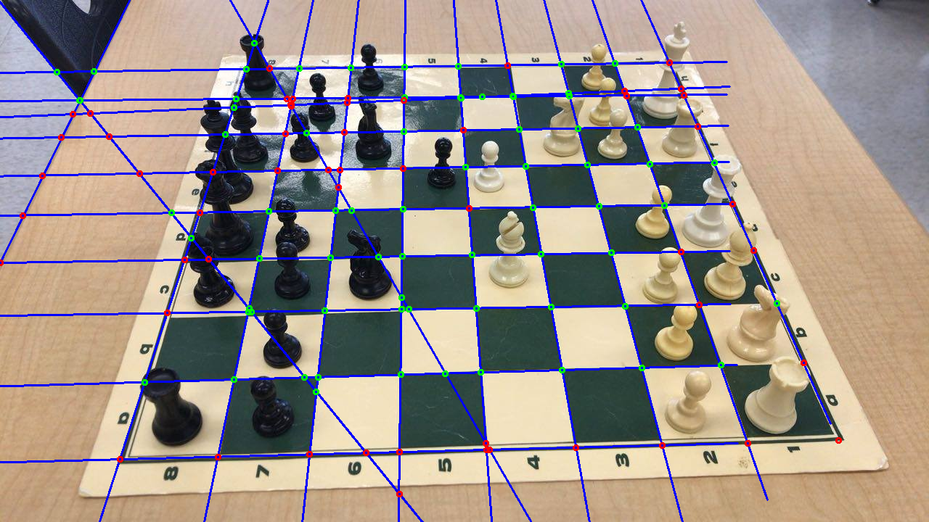

Looking at the image, it’s clear to see that the CNN is far from perfect. It correctly identifies lots of the easy examples of lattice points, but it starts to fail when pieces are surrounding the area. This is most likely either due to the piece itself actually confusing the network or due to the shadow from the piece confusing the network. For the edge cases, it properly identifies the whole bottom row as negative (lattice points are only the intersections in the middle). However, it has trouble with the other three edges and the top edge is the worst out of the four. I’m guessing this is due to a lack of training examples, so I will be adding more of those to my dataset. Overall, the initial performance of the network is subpar, so I will be training the network even more.

Aside from that, Kevin Fu and I are working on implementing Snowy with our software so we can run model prediction and OpenCV functions on the GPU.